Major Gas Explosion - Tewksbury MA - February 9, 1972
Headline and Excerpts from various newspapers Courtesy of Ed Kearns CW134
Compilation by SW91

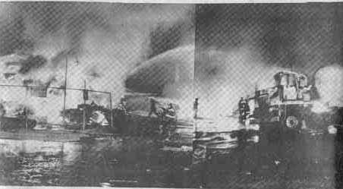

Residents Feared an Earthquake

TEWKSBURY MA -- For several horrifying seconds a wave of fear gripped residents here and in neighboring communities whose immediate reaction ran from a sneak bombing attack to an earthquake.

A Florence Ave resident said "The blast shook the house though it was going to fall apart". A Tyngsboro resident, on Woodlawn Street exclaimed, "The blast shook the house and rattle the hell our of the windows. I though it was a bomb and braced myself for the next blast".

Remembrance Mass will honor lives lost in 1972 tragedy

Remembering the 1972 Lowell Gas Disaster
Jake Peterson

TEWKSBURY MA -- The call came to the Tewksbury Fire Department through as a routine fire at 10:39p.m. Firefighter Ed Kearns, who then in his third year on the job, heard the call come over the scanner while off duty and proceeded to the closest fire station, where he attempted to join the next crew that was headed to the scene. Kearns's commanding officer, Fire Chief William Chandler, stopped Kearns from joining his comrades already in route to the fire because he lacked the proper equipment.
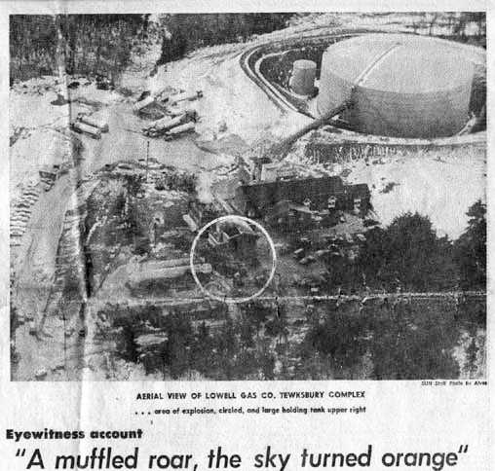
Lowell Gas Complex

Lowell Gas Complex

Lowell Gas Complex
"I knew my equipment was at the other firehouse some miles away, but nonetheless wanted to go out on the call on its second alarm".

Kearns was left at the fire station to man the phones. As the Chief arrived at fire a few minutes after 11p.pm. he found firefighters working to stifle the blaze from the busted pipe. Flames were shooting 60 feet into the air. The firefighters were also cooling down the large storage tanks that stood nearby in an attempt to keep them from igniting.

Chief Chandler gave the order for his firefighters to retreat as the tanker truck now had a small fire burning underneath it. As they retreated, the flames ignited the tanker truck and sent a mushroom cloud into the sky. The cloud, which was shaped like on from an atomic blast, was witnessed by pilots as far as fifty miles away.

Tewksbury Gas Blast Injures 40

TEWKSBURY MA -- The fire in the tank touched of a series of small explosions which drew several hundred people from Billerica Trailer Park, located less than 100 yards from the gas fire scene.

Seconds later witnesses said, "It erupted into one tremendous explosion, which fell 16 firefighters and an equal number of spectators.

Fire Engine Destroyed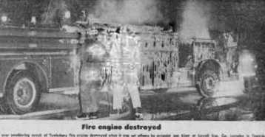

Photo Caption A Tewksbury fire engine was destroyed when it was set aflame by propane blast at Lowell Gas Co. complex in Tewksbury.

The explosion

Photo Caption This photo was taken at the instant propane gas truck in the yard of the Lowell Gas Co. in Tewksbury exploded, sending a fireball hundreds of feet into the sky. Veteran Sun photographer Tony Alves was knocked down by the blast seconds after taking the picture.

Tewksbury blast probed; tank truck driver dies

TEWKSBURY MA -- Feb 11, 1972 - Several agencies have opened investigations into the cause of a propane gas explosion in Tewksbury which took one live, injured 21 and forced evacuation of 700 people from surround dwellings.

Dead as a result of burn is Arthur Sutcliff, 50, of Lowell, a truck driver who was making a delivery at the plant and who apparently backed his 8500 gallon tank truck into a gas line, snapping it and allowing the vapor to escape.

The explosion shortly after 11p.m. Wednesday at a Lowell Gas Co. plant on Chapman Road sent up a huge fireball which could be scene 30 miles away.

Probers seek gas blast's cause

Nick Caraganis - Lowell Sun

TEWKSBURY MA -- The state Department of Public Utilities has called for a hearing to determine the exact cause of a general alarm fire and explosion at the Lowell Gas Company Complex which took the life of a Lowell truck driver and has a Tewksbury Fireman fighting for his life.

"we are looking for anything wrong. This on its face look like human failure. The truck apparently backed into the gas pipe. This is all we see now."

Inspectors from the DPU, the State Fire Marshal's office, the Dept. of Public Safety and the Dept. of Transportation along with local fire officials have begun extensive investigation into the incident.

State Fire Marshal Ralph Garret said he has dispatched state police detectives to the scene and said the consulting firm of Arthur D. Little Co. of Cambridge also will aid his agency in investigating the explosion and general alarm fire.

Meanwhile, almost one half of the Tewksbury Fire Department, several gas company employees and a Lowell Sun reporter remained confined to the hospital.

Deputy Chief James Morris, who underwent emergency surgery early Thursday morning after suffering a skull fracture is reported in "stable" condition in the Intensive Care Unit of St. John's Hospital. Officials said he is in "fair" condition. Tewksbury Fire Chief William Chandler is reported in "good" condition suffering burns on his hands.

It has been a long haul, but fire department is back to normal

May 28, 1972 - Lee Wood - Lowell Sun

TEWKSBURY MA -- It's been a long time since Feb. 9, when a propane truck exploded at the Lowell Gas Company on Chapman Road, but the fire department finally is back to almost normal.

Two men are still out. Fourteen firefighters has to be taken to St. John's Hospital in Lowell because of the explosion which killed a truck driver and call fireman William McAllister.

Still not working are Larry Nawn who is getting treatment for blocked up ears and John Fields who sustained knee injuries

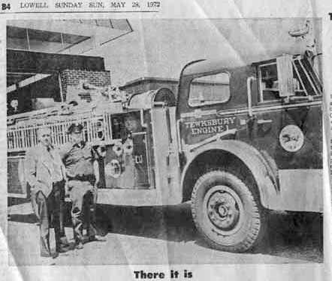

Photo Caption Tewksbury Chief William Chandler and fireman Ken Mallison proudly stand by the new Engine 1 delivered May 1. It replaces Engine five destroyed in the Feb 9 gas explosion. The apparatus features a 1250 gallons per minute pumper, a 50 gallon water tank, 1000 gpm for the deluge gun and a high expansion foam system. Because of cooperation from American LaFrance, the engine was delivered quickly. Normally delivery takes about 1½ years.

Residents Still Feeling Explosion Shock Waves

One Dead : Score Injured – Disaster Raises Many Question

It was 10:39p.m. The air was still and crisp and most of Tewksbury was setting in to a two blanket night. Only Friday left, then a two-day reprieve from the drudgery of a mid-winter work week.

The call that interrupted the week-end plans of many.
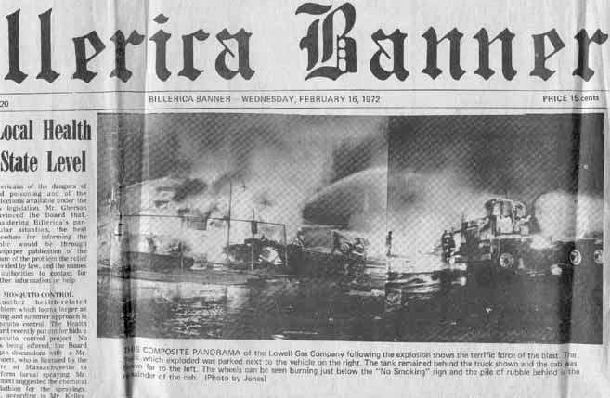

A small fire at the loading platform at the Lowell Company's storage facilities on Chapman Road. Fairly routine, except this was gas.

A few minutes later, a radios request for a second alarm.

Twenty minutes later, an ear splitting explosion that shook the surrounding community to its eyeteeth, killing a gas company employee, wiping out nearly half the Tewksbury Fire Department, including the chief, deputy, and two truck sending a fireball into the sky that could be seen 50 miles away.

A half hour later the town of Tewksbury was in a state of shock.

The town resembled a disaster area as ambulances, rescue units, sophisticated fire fighter equipment from surrounding towns, police and spectators closing every road leading into the area.

Confusion, conjecture, rumor and fear spread through the town like the wildfire which created it.

How bad it was, how worse it could get, the extent of the dead or injured, non one knew.

Police were scurrying around attempting to evacuate families in the immediate neighborhood.

The were later reports of looting.

The fire department switch board lit up like a Christmas tree as worried families sought information about loved ones who had been sent to the blaze, and for fear of completely tying up communications, calls had to be referred to the police department.

Three foam truck from Hanscom Field in Bedford finally brought the fire under control about 12:30a.m.

Fireman William J. McAllister was taken to Massachusetts General Hospital with third degree burns. Deputy Chief James Morris was in intensive care at St. John's Hospital, Lowell where he underwent a two hour operation for a skull fracture.

A cinder block building in the complex had been completely destroyed and another heavily damaged. The cab of a fully loaded 8500 gallon propane truck had been block 75 feet in one direction and half the talk section nearly 300 feet in the other.

At 5:15a.m. the Lowell Gas Company issued a statement that a minor fire at the plant was under control.

MORE TO FOLLOWING AS TIME ALLOWS: LAST UPDATE FEB 23, 2004

I like to thank Ed Kearns, Retired Tewksbury Fire Officer, for provided a ample collection of newspaper clips for this compilation. Ed was in his third year with the Tewksbury Fire Department when this disaster struck. Just as Ed honored our fallen heroes from 9/11 by attending scores of funeral and memorial services in New York City, he offered his collection in order to honor the memory of those killed and injured in this local tragedy. (SW91)

